Step 1: ng g service services/todos

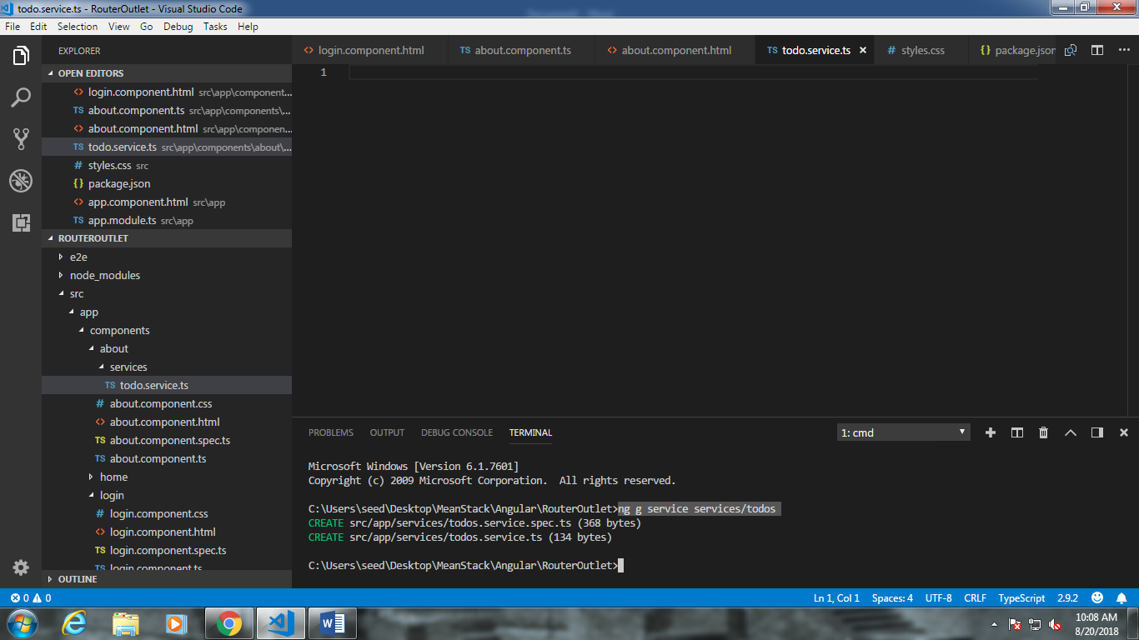

2. Register HttpClientModule in app.module.ts

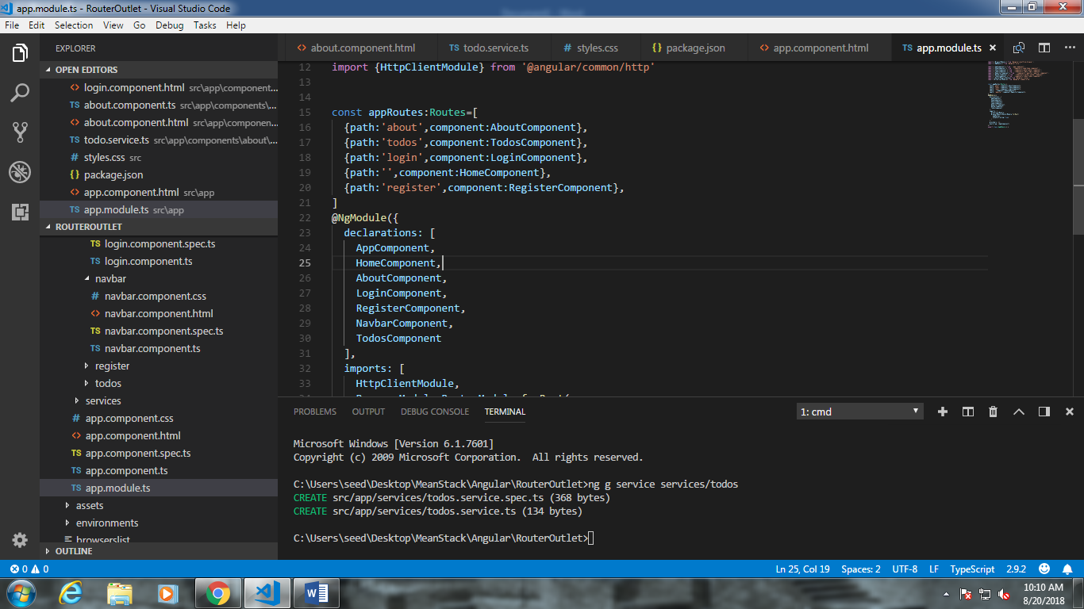

3. Register TodoServcie

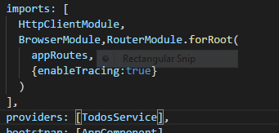

4. Go to todo.sercice and import HttpClient

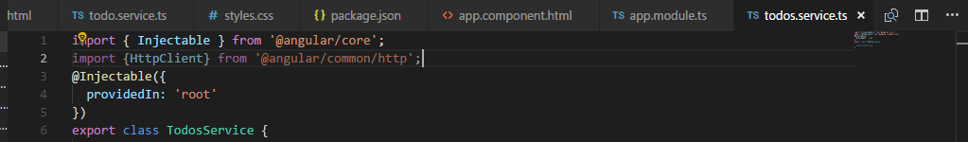

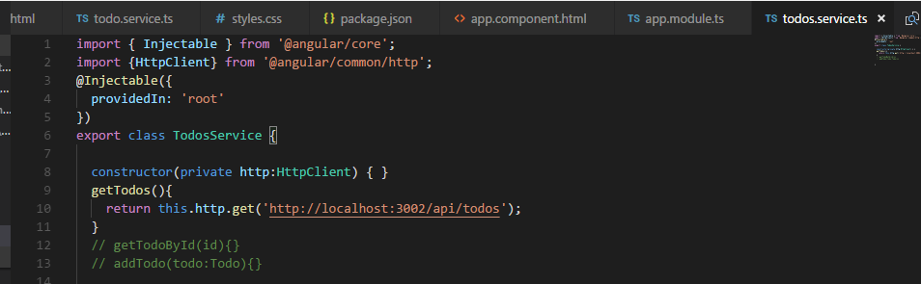

5. Consume todoService in todos component. Special method subscribe() because it’s an asynchronous communication and http.get() returns observable

(subscribe returns data when evailable)

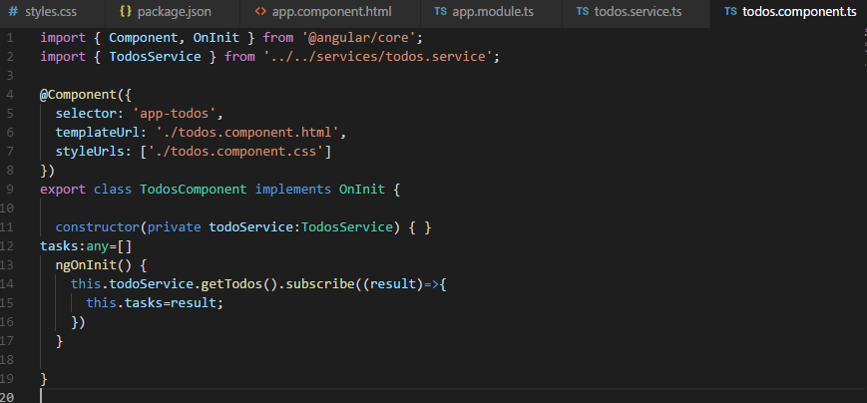

6. Iterate over tasks

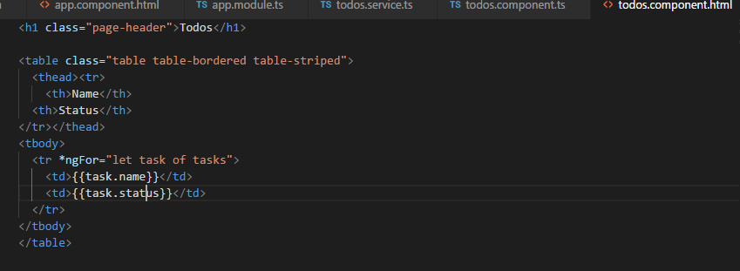

7. include cors to allow cross origin request (Angular->service->express->Mongo)

Run express as well as angular

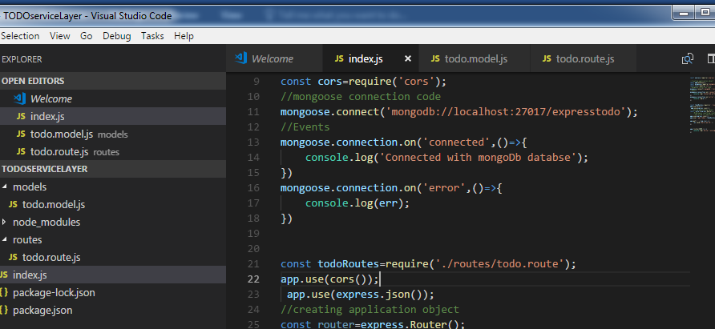

8.Delete data from table

Todos.service.ts

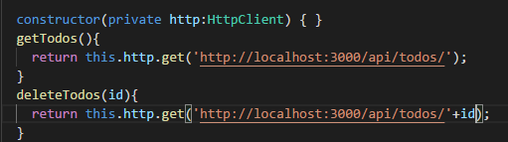

9. todo.component.ts

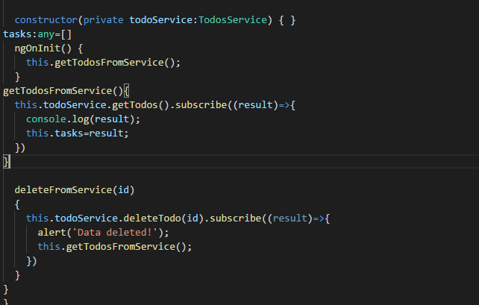

10. todo.component.html;

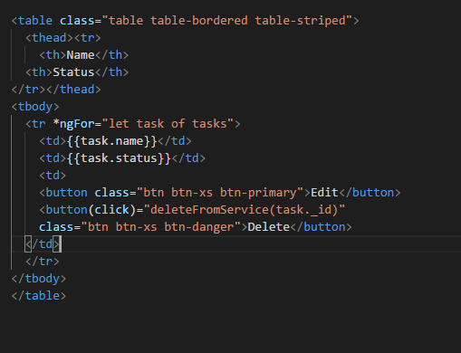

Todo.service.ts

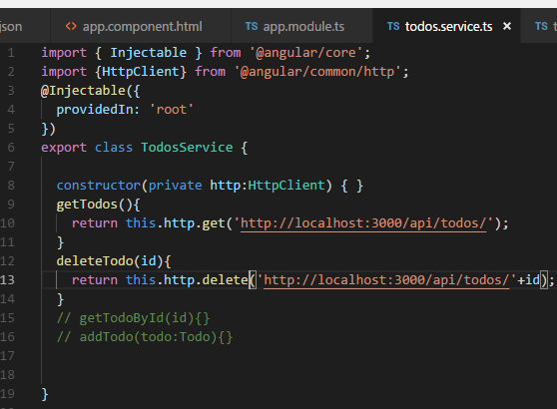

11. Add new task.. Generate todo-create component (enter new task in textarea)

ng g c components/todo-create

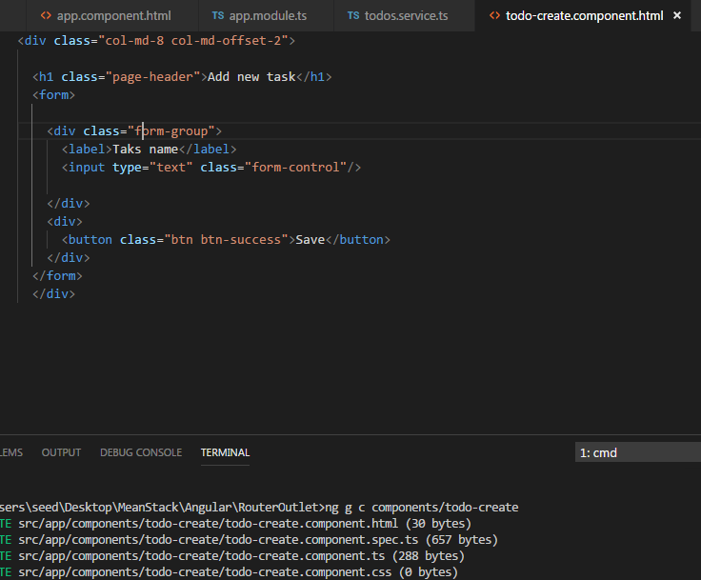

App.module.ts

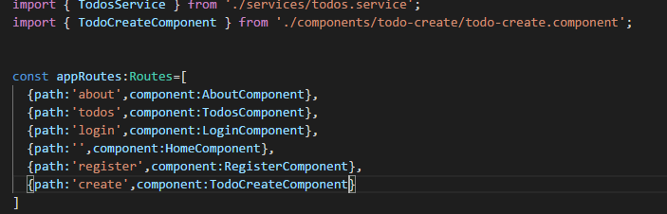

Todos.component.ts

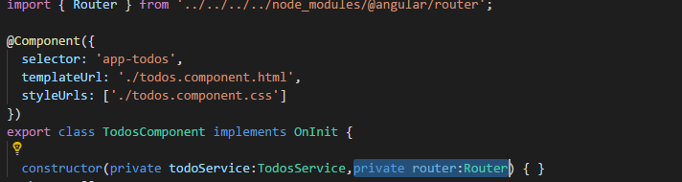

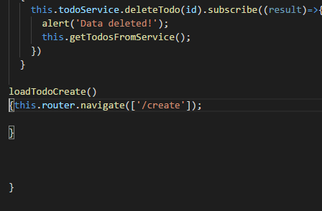

Todos.component.html

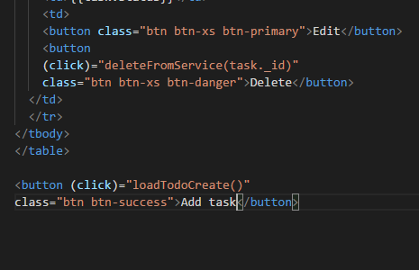

Todo.service.ts:

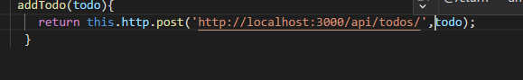

Todo-create:

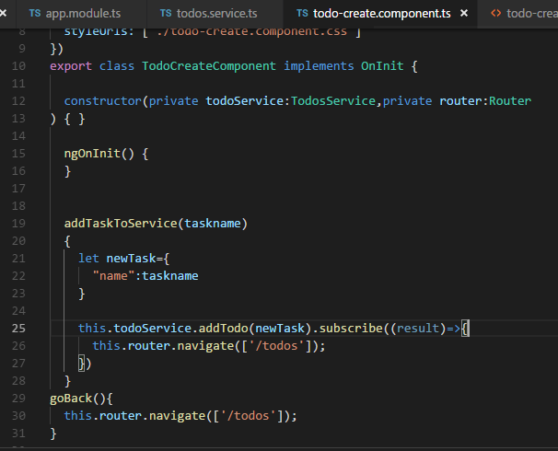

Update task (edit)

Make Edit component, .html:

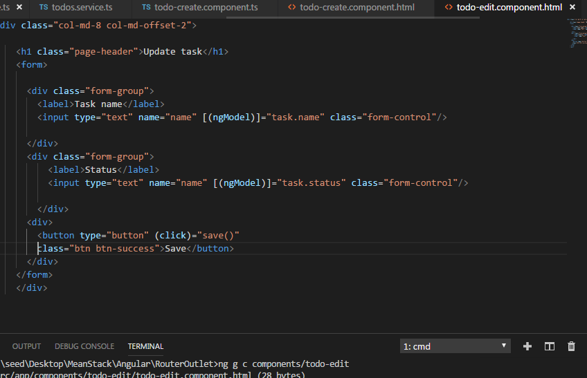

Todo.component.html:

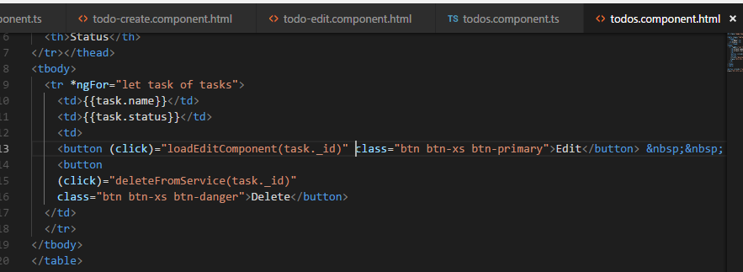

Todo .component,ts

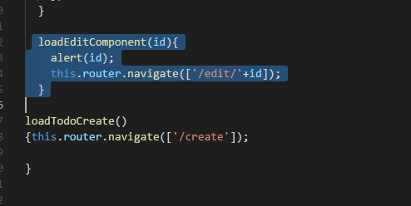

App.module.ts:

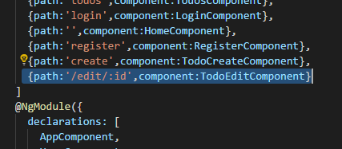

Todos.service.ts:

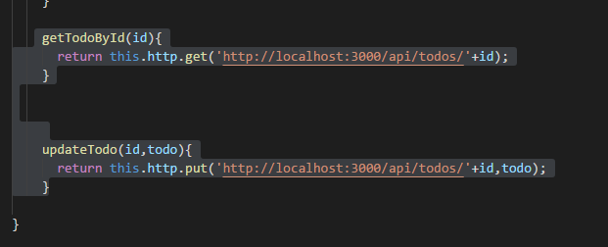

Todo edit component.ts:

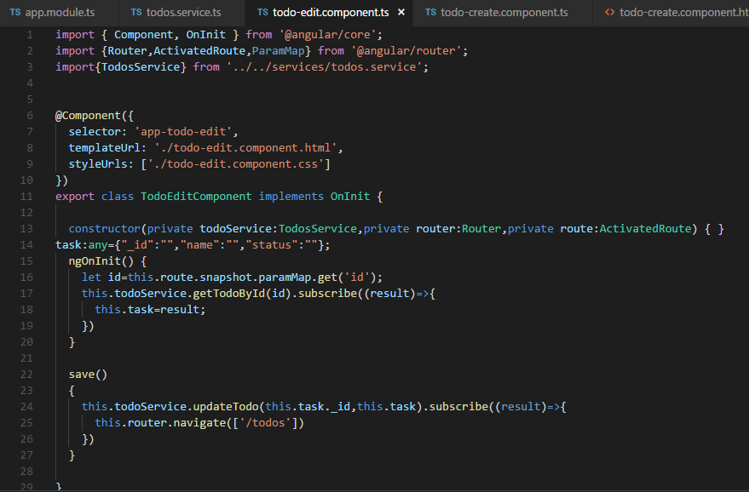

Validations in login.html



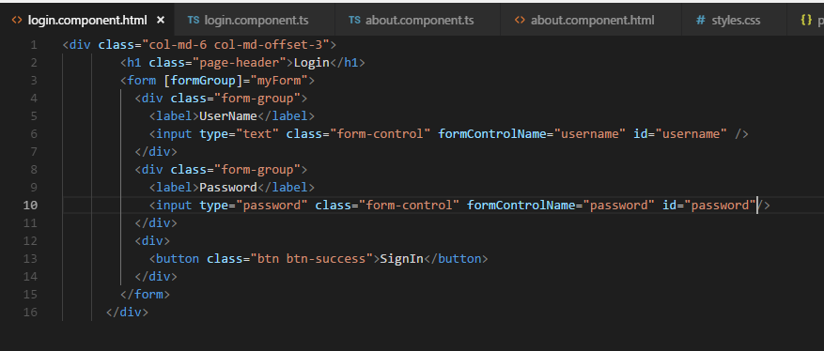

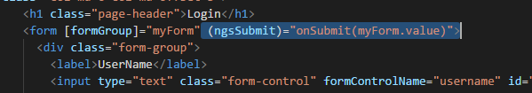

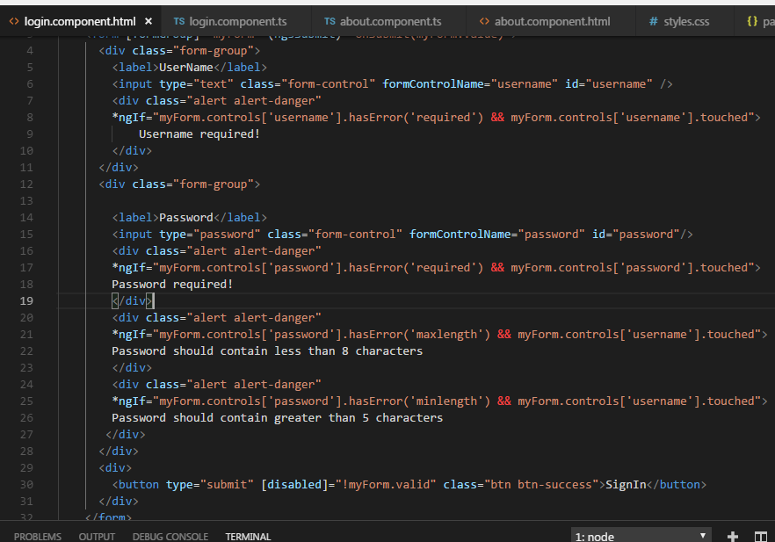

Login.component.ts

